ONLINE FORM

**Software Requirements Specification**

Version 1.0



**Group Id: S23027572B (BC180400031)**

**Supervisor Name :Usman Waheed Bhatti**

**Revision History**

|  |  |  |  |
| --- | --- | --- | --- |
| **Date (dd/mm/yyyy)** | **Version** | **Description** | **Author** |
| 25/05/2023 | 1.0 | Welcome to our online form application! Say goodbye to the hassle of traditional paperwork and embrace the convenience of digitized forms. With our user-friendly interface and seamless integration, filling out forms has never been easier. Experience a new era of efficiency and simplicity with our innovative online form application. | bc180400031 |
|  |  |  |  |

**Table of Contents**

1. Scope (of the project)
2. Functional Requirements&Non Functional requirements
3. Use Case Diagarm
4. Work Plan

**SRS Document**

**1. Scope of Project:**

The scope of our Final Year Project (FYP) is to develop a comprehensive online form application similar to Google Forms. The application will allow users to create, customize, and share online forms for various purposes such as surveys, registrations, feedback collection, and more. It will incorporate features like conditional logic, multiple question types, data validation, and real-time analytics. The goal is to provide an intuitive and efficient platform for form creation and data collection, empowering users with a versatile tool for their diverse needs.

Our goal is to deliver a robust and efficient online form application that meets the needs of various users and simplifies the form-filling process.The application will provide a secure login system and enable form creators to define questions, answer choices, and submission limits. The results will be stored in a database and accessible to the form creator.

**2. Functional and non Functional Requirements:**  
**2.1Functional Requirement**

**2.1.1 Secure Login**

Users shall be able to sign up with a valid email ID and create an account.

The application shall provide secure access with login credentials.

User authentication and session management shall be implemented to ensure secure login. Once signed up and logged in, the Form Creator will have exclusive access to the application's features and functionalities. The secure login ensures that only authorized individuals can access the Form Creator's account and the associated data.

**2.1.2 Form Creation**

Form creator invite guest user to fill form throghh email.

**2.1.3 Form Creation**

Users shall be able to create up to 10 forms.

The application shall support various question types such as short answer, long answer, dropdown fields, checkboxes, and radio buttons.

The form creator shall have the option to mark certain questions as required.

Each form can contain maximum 10 questions.

**2.1.4 Form Submition Limitation**

The form creator shall be able to set a submission limit for each form, specifying a specific date and time until when the form can be filled by guests.

The application shall enforce the submission limit and prevent further submissions after the specified deadline.

**2.1.5 Result Storage and Export Data**

The results of form submissions shall be stored in a database.

The form creator shall have access to view and manage the form results.The results shall be presented in an organized manner, with columns representing the questions and rows representing the guest responses.

The application shall provide an option for the form creator to export the results in an Excel sheet format.

**2.2 Non Funtional Requirement**

**2.2.1 Security:**

The application must be secure. Login credential must be stored in encrypted form. Data must be secure with different sercuriy measures. Data must not be breached.

**2.2.2Usability:**

The U.I must be user friendly for better experience. The system should provide appropriate feedback and validation to users when creating forms or filling them out.

**2.2.3 Scalability:**

The system should be designed to handle a potentially increasing number of users and forms without significant degradation in performance.

It should be able to accommodate future growth and increased data storage requirements.

**2.2.4 Scalability:**

The application must be designed in such a way that enhancement in the future would be implemented easily.

**3.Use Case Diagram**

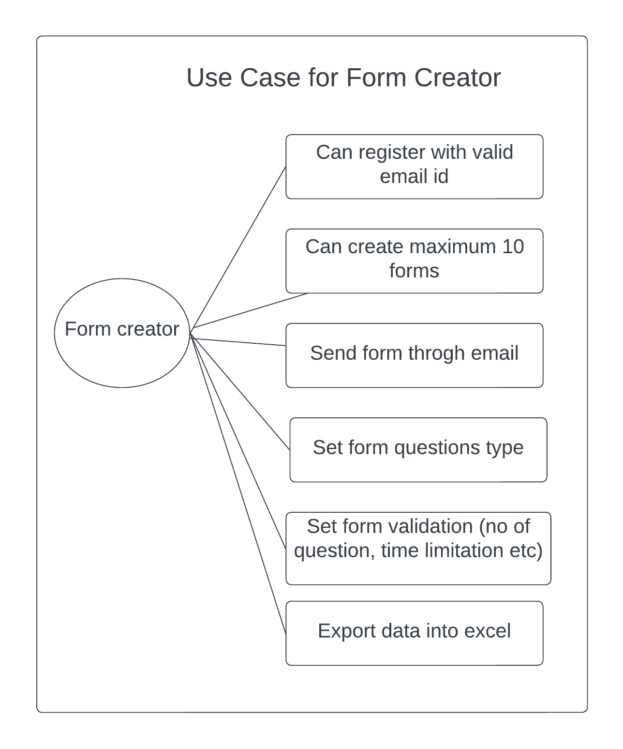

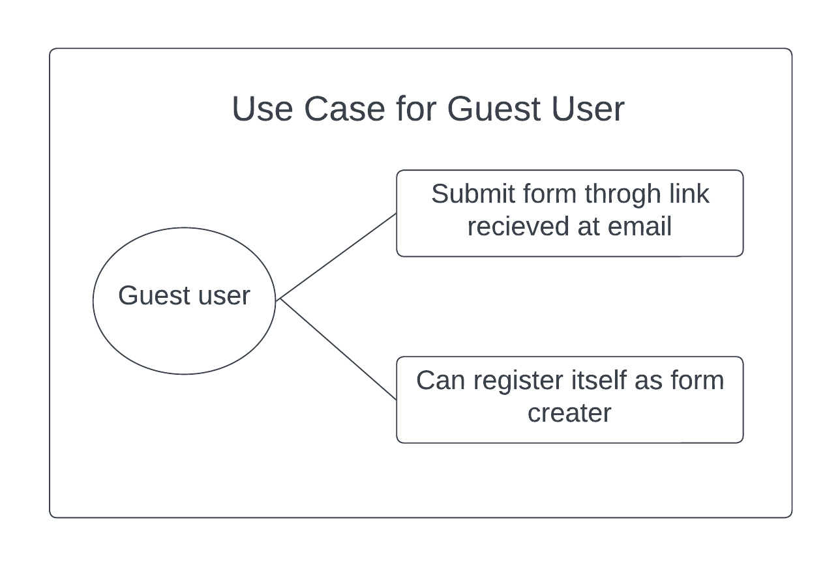  
  
  
**3.1 Usage Scenarios**

|  |  |
| --- | --- |
| Use Case Title | Registration |
| Use Case Id | OFUS-1 |
| Users | Form creator |
| Actions | A user will open the application. Fill the registration form. |
| Description | The user opens the application there he finds the login link. If he was not registered yet there will be an option to create an account and to create forms. He will access that registration page and by providing the required information he will register himself. |
| Pre-Condition | Application is available, the Internet is available, must not be a user with the same email, the registration page is accessible. |
| Post-Condition | Checking of provided information of the user if all correct then return a message or a confirmation message to the user. |
| Exception | Server response provided email id must not be registered already. |

|  |  |
| --- | --- |
| Use Case Title | Login |
| Use Case Id | OFUS-2 |
| Users | Form creator(user) |
| Actions | The user will open the application. Access login page and log in by email id and password. |
| Description | After opening the application user access the login page. Userlogin himself by providing email and password to access form creation page/portal. |
| Pre-Condition | The user must be registered into the application before login in. |
| Post-Condition | Return message or confirmation message. If user login successfully then a user portal is provided to them. |
| Exception | Email and Password must be matched to an existing user. |

|  |  |
| --- | --- |
| Use Case Title | Form creation |
| Use Case Id | OFUS-3 |
| Users | Form creator(user) |
| Actions | The user will open the application. Access create form page if logged in. |
| Description | After opening the application user access create form page. If user not logged in then redirect user to login page other wise form opens and user put necessary detail and form validations. |
| Pre-Condition | The user must be registered into the application amd logged in. |
| Post-Condition | Return message or confirmation message of form submission. |
| Exception | Required condition must be filled. |

|  |  |
| --- | --- |
| Use Case Title | Form Submission. |
| Use Case Id | OFUS-4 |
| Users | Guest user |
| Actions | The user will open the application. Access form page if opened by validate link. |
| Description | User open form submission page through link and filled the necessary details and submit it. |
| Pre-Condition | The user must open page through invited link. Form must not be closed. |
| Post-Condition | Return message or confirmation message of form submission. |
| Exception | Required condition must be filled. |

|  |  |
| --- | --- |
| Use Case Title | Export data |
| Use Case Id | OFUS-5 |
| Users | Form creator |
| Actions | User clicked on export button that is shown when form filled atleast one time. |
| Description | If form is summited atleast one time then export button is shown to form creator and te data of that form export into excel formate with question in column and answer in rows. |
| Pre-Condition | Form must be filled atleast one time |
| Post-Condition | Data must be exported into excel file. |
| Exception | Empty field must be handle. |

**4. Work Plan**



